
YENEPOYA INSTITUTE OF ARTS, SCIENCE, COMMERCE AND MANAGEMENT
BALMATTA, MANGALORE

Project – High Level Design
on
Identity Security Framework for Edtech

Student Name: Sona V

Industry Mentor:  Divya N Shetty |  | Guided by: | Shashank

Table of Contents

- Introduction. 6
  - Scope of the document. 6
  - Intended Audience 6
  - System overview. 6
- System Design. 6
  - Application Design 6
  - Process Flow. 6
  - Information Flow. 7
  - Components Design 8
  - Key Design Considerations 8
  - API Catalogue. 8
- Data Design. 8
  - Data Model 8
  - Data Access Mechanism 9
  - Data Retention Policies 9
  - Data Migration 9
- Interfaces 9
- State and Session Management 10
- Caching 10
- Non-Functional Requirements 10
  - Security Aspects 10
  - Performance Aspects 10
- References 11

- INTRODUCTION
An EdTech system is an online platform that allows users to access and learn courses through digital technology. With the increasing use of online education, ensuring secure access and proper user management has become very important. One of the key challenges in such systems is maintaining identity security, where only authorized users can access specific functionalities. This project implements an Identity Security Framework for an EdTech application using Flask and SQLite. The system allows users to register and log in securely, with passwords stored using hashing techniques to protect sensitive information. Once authenticated, users can view available courses and enroll in them. The system also introduces role-based access control, where different roles such as user, instructor, and admin have different permissions. Instructors can manage courses in the system, while users can enroll and access course content. An admin is responsible for managing users and courses, ensuring controlled and secure system operation. Additionally, the system includes an enrollment management feature where users can enroll in courses and the system ensures that duplicate enrollments are prevented. Sessions are used to track logged-in users and manage their access throughout the system. Overall, this project demonstrates the concepts of authentication, authorization, secure data handling, and controlled workflow in a simple EdTech environment.

1.1 SCOPE OF THE DOCUMENT
This document describes the design and implementation of an identity security framework for an EdTech system. It provides detailed information about the system architecture, data flow, components, and technologies used, including Flask, HTML, CSS, and SQLite. The document focuses on secure authentication, role-based authorization, course management, and enrollment handling within the application.

1.2 INTENDED AUDIENCE
This document is useful for:
- Students developing similar web-based projects
- Developers working on secure EdTech applications
- Beginners learning authentication and authorization in Flask

1.3 SYSTEM OVERVIEW
The system overview provides a general understanding of how the EdTech application works. The system allows users to register and log in securely using their credentials. After successful authentication, users can access the dashboard where they can view available courses and enroll in them. The system is designed with role-based access control, where different users have different functionalities. A normal user can view courses and enroll in them. An instructor can manage courses by adding and updating course details. An admin is responsible for managing users and courses within the system, ensuring controlled and secure operations. The system also includes an enrollment management mechanism. When a user enrolls in a course, the system checks whether the user is already enrolled in that course. If not, the enrollment is recorded; otherwise, duplicate enrollment is prevented. All user activities are managed using session handling, which maintains the login state and controls access to different parts of the system. The frontend is developed using HTML and CSS (with Tailwind), while the backend is implemented using Python Flask and SQLite for data storage.

2. SYSTEM DESIGN

2.1 APPLICATION DESIGN
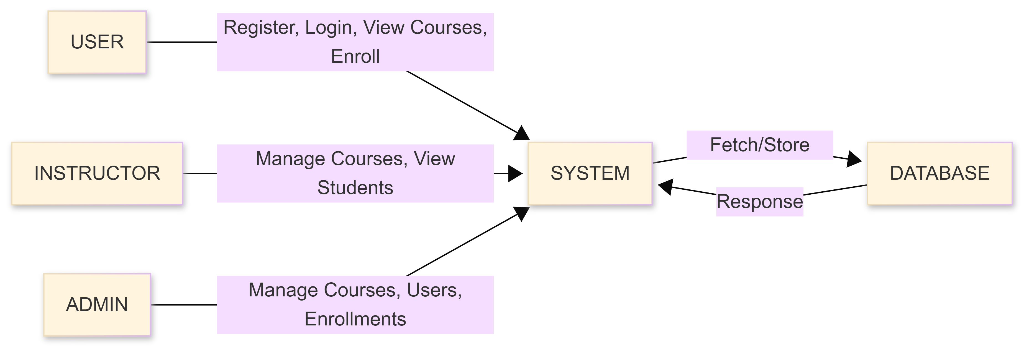

This diagram shows the complete architecture of the E-commerce system with an identity security framework. It explains how the user, frontend, backend, and database interact with each other to provide secure and controlled functionality.The process starts with the User (Client), who uses a web browser to interact with the system. Depending on their role (user, shopkeeper, or admin), they can perform different actions such as registering, logging in, viewing products, adding products, placing orders, or approving products.These actions are handled by the Frontend UI, which is built using HTML and CSS (Tailwind). The frontend provides different pages such as login, register, dashboard, product listing, and admin panel. It sends user requests to the backend using HTTP methods. The Backend Server (Python Flask) acts as the core component of the system. It handles authentication (login and registration), manages user sessions, and enforces authorization using role-based access control. It processes all requests such as adding products, approving products, and placing orders.
The backend also implements important business logic. When a shopkeeper adds a product, it is stored with a "pending" status. The admin reviews and updates the status to "approved" or "rejected". Only approved products are made visible to users. Additionally, when a user places an order, the backend checks the available stock and updates the product quantity accordingly.

The system interacts with the Database (SQLite), which stores all necessary data such as user details, product information, and order records. The backend retrieves and updates this data as required, ensuring consistency and secure access. Overall, the architecture ensures a clear separation between frontend, backend, and database, while maintaining secure authentication, controlled access, and proper data management. The system also interacts with the Database, which stores important data such as user details, preferences, and ratings. The backend fetches and updates this data when needed.

2.2 PROCESS FLOW
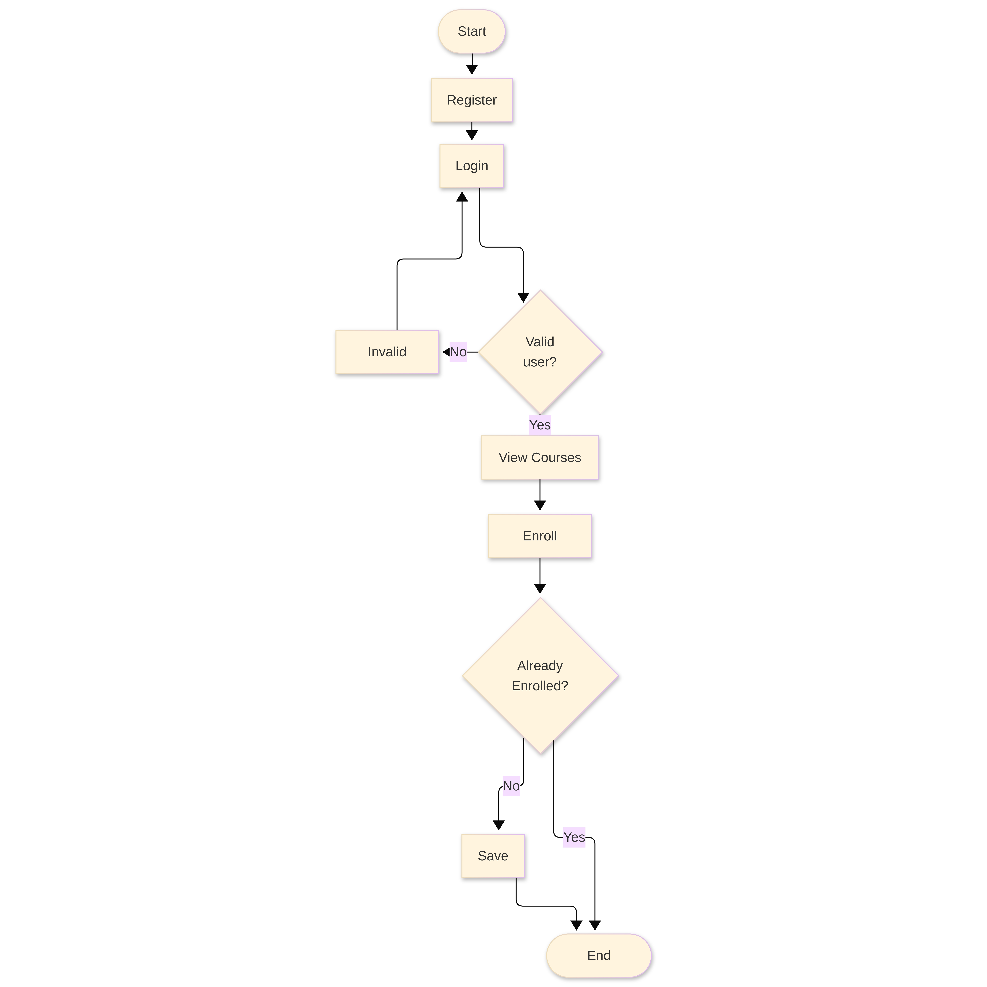

The process starts with the user accessing the system. First, the user needs to register by creating an account with an username and password. After successful registration, the user logs in using their credentials. The system verifies the login details, and if the credentials are incorrect, an error message is displayed and the user is asked to try again. This process continues until valid credentials are provided.

Once the user is authenticated, a session is created to maintain the user’s login state. Based on the role of the user (user, shopkeeper, or admin), the system

provides access to different functionalities. If the user is a shopkeeper, they can add new products by providing details such as name, price, description, and quantity. These products are initially stored with a "pending" status. The admin then reviews these products and either approves or rejects them. Only approved products are made visible to users.
A normal user can view the list of approved products. When placing an order, the system checks the available stock for the selected product. If sufficient quantity is available, the order is processed and the product quantity is reduced accordingly. If not, an appropriate message is displayed. The admin can manage users, monitor products, and control the system through the admin dashboard. Throughout the process, all actions are controlled using session-based authentication and role-based authorization to ensure secure access.

2.3 INFORMATION FLOW
Information flows between different components of the EdTech system in a structured manner. User input is first captured through the frontend interface, which includes pages such as login, course listing, and dashboard. These inputs are sent to the backend server using HTTP requests. The backend (Flask application) processes the received data and performs necessary operations such as authentication, authorization, course management, and enrollment processing. It interacts with the database to store and retrieve information like user details, course data, enrollment records, and feedback.
When an instructor adds or updates a course, the data is stored in the database and made

available to users. Users can view courses and send enrollment requests. When a user enrolls in a course, the backend checks whether the user is already enrolled in that course. If not, the enrollment is recorded; otherwise, duplicate enrollment is prevented. The updated information is stored in the database and reflected in the frontend.
All responses from the backend are sent back to the frontend and displayed to the user. The session mechanism ensures that user identity and role information are maintained throughout the interaction, enabling secure and controlled access to the system.

2.4 COMPONENTS DESIGN
The system has the following components:

USER
• Register/Login: This module allows users to create an account and securely log in to the system. User credentials such as username and password are stored in the database, with passwords protected using hashing techniques.
• View Courses: Users can view a list of available courses. Only courses managed by the system are displayed for enrollment.
• Enroll in Course: This module allows users to enroll in courses. The system ensures that a user cannot enroll in the same course multiple times.
• View Enrolled Courses: Users can view the courses they have enrolled in and track their learning progress.

INSTRUCTOR
• Register/Login: Instructors can create an account and log in to manage their courses within the system.
• Manage Courses: Instructors can add and manage course content and details.
• View Enrolled Students: Instructors can view the list of students enrolled in their courses.

• View Feedback: Instructors can view feedback given by users for their courses.

ADMIN
• Login: Admin can log in to access the system with full control over all modules.
• Manage Users: Admin can view all users and instructors and take actions such as blocking or managing accounts.
• Manage Courses: Admin can add, update, or delete courses in the system.
• View Enrollments: Admin can monitor all course enrollments.
• Monitor System: Admin oversees the overall functioning of the system to ensure proper operation and security.

2.5 KEY DESIGN CONSIDERATIONS
- Security:
The system uses login and role-based access so only authorized users can perform actions.
- Simple Design:
The system is easy to use with a simple interface.
- Data Accuracy:
Product quantity is updated after each order to avoid mistakes.
- Controlled Access:
Admin controls product approval, and users have limited access.

2.6 API CATALOGUE
The system uses APIs such as:
• Login API
• Register API
• Course API
• Enrollment API
• Admin Management API

3. DATA DESIGN
Data design explains how data is stored, organized, and used in the EdTech system. It is an important part of the system because all operations such as user login, course management, and enrollment processing depend on stored data. The system stores different types of data such as user details, course information, enrollment records, and feedback. All data is stored in a structured database (SQLite) so that it can be easily accessed and updated. Proper data design helps the system work efficiently and ensures accurate processing of user requests. For example, when a user logs in, the system checks the stored user data. When a course is added or a user enrolls, the system updates the course and enrollment data accordingly.
3.1 DATA MODEL
Users Table
SL.no | Column name | Data type | Size | Constraints | Description
1 | id | INT | 11 | Primary Key | User ID
2 | username | VARCHAR | 200 | Not Null | Username
3 | password | VARCHAR | 200 | Not Null | Hashed Password
4 | role | VARCHAR | 50 | Not Null | User Role (user/instructor/admin)

Courses Table
SL.no | Column name | Data type | Size | Constraints | Description
1 | id | INT | 11 | Primary Key | Course ID
2 | name | VARCHAR | 200 | Not Null | Course Name
3 | instructor | VARCHAR | 200 | Not Null | Instructor Name

Enrollments table
SL.no | Column name | Data type | Size | Constraints | Description
1 | id | INT | 11 | Primary Key | Enrollment ID
2 | user_id | INT | - | Not Null | User ID
3 | course_id | INT | - | Not Null | Course ID

Feedback Table
SL.no | Column name | Data type | Size | Constraints | Description
1 | id | INT | 11 | Primary Key | Feedback ID
2 | user_id | INT | - | Not Null | User ID
3 | course_id | INT | - | Not Null | Course ID
4 | message | TEXT | - | - | Feedback Message

3.2 DATA ACCESS MECHANISM
Data is accessed through Flask routes that handle requests such as login, viewing courses, and enrolling in courses. The backend uses SQL queries to interact with the SQLite database. It retrieves data like user details and course information when required and inserts new records when a user enrolls in a course. The system also checks existing enrollment data before inserting new records to prevent duplicate enrollments. This ensures that data access is controlled, efficient, and consistent with the application logic.

3.3 DATA RETENTION POLICIES
User data, course details, enrollment records, and feedback are stored securely in the database. This data is retained as long as it is required for system functionality, such as tracking enrolled courses and managing users. If any data becomes unnecessary, such as outdated records, it can be removed or updated by the admin. Proper retention ensures that the system remains efficient while maintaining necessary information for operations.

3.4 DATA MIGRATION
If the system is upgraded or moved to another environment, the existing data can be migrated using database export and import tools. Since the system uses SQLite, the database file can

be easily transferred without loss of data. Proper migration ensures that user accounts, course details, and enrollment records remain intact and the system continues to function correctly after updates.
4. INTERFACES
Interfaces define how users and system components interact with the application. In this project, the main interface is the user interface (UI) developed using HTML and CSS (Tailwind). It includes pages such as login, registration, dashboard, product listing, and admin panel. These pages are designed to be simple and user-friendly so that users can easily navigate the system.
The system also uses API interfaces to connect the frontend and backend. The frontend sends requests (like login, adding products, or placing orders) to the Flask backend using HTTP methods such as GET and POST. The backend processes the request and sends a response back to the frontend. All interfaces work together to ensure smooth communication and proper functioning of the system.

5. STATE AND SESSION MANAGEMENT
State and session management are used to maintain user information during interaction with the EdTech system. When a user logs in, a session is created on the server using Flask. This session stores important data such as user ID and role (user, instructor, or admin).
The session ensures that the user does not need to log in again while moving between pages like course list, enrollment, and dashboard. It also helps in controlling access to different features based on user roles. For example, only instructors can manage courses, and only admins can manage users.
Secure session handling is important to protect user data. Techniques like session timeout and secure cookies help prevent unauthorized access. Proper session management improves both security and smooth navigation in the system.

6. CACHING
Caching is used to improve system performance by temporarily storing frequently accessed data. Instead of processing the same request multiple times, cached data can be quickly returned when needed.
In this system, course data and frequently accessed information such as course listings can be cached. This helps in reducing database load and improves response time when multiple users are accessing courses.
Caching can be implemented using simple techniques if required. It helps the system perform efficiently, especially when many users are using the platform at the same time.

7. NON-FUNCTIONAL REQUIREMENTS
Non-functional requirements define how the system performs rather than what it does. These include performance, security, usability, and scalability.
The system should be reliable and available to users. It should handle multiple users without issues. The interface should be simple and easy to use.
The system should also be scalable, meaning it can support more users and data as needed. Proper design ensures the system continues to work efficiently.

Security Aspects: Security is important because the system handles user data. The system uses authentication to allow only valid users to log in. Passwords are stored securely using hashing techniques. Role-based access control ensures users can only access allowed features. Session management is also secured to prevent unauthorized access.

Performance Aspects: Performance refers to how fast and efficiently the system works. The system provides quick responses when users perform actions like viewing products or placing orders. Database queries are simple and optimized to fetch data quickly.

8.REFERENCES

[1] Flask Documentation – https://flask.palletsprojects.com
[2] SQLite Documentation – https://www.sqlite.org
[3] Werkzeug Security (Password Hashing) – https://werkzeug.palletsprojects.com
[4] Web-Based Learning Systems Overview
[5] Role-Based Access Control Concepts

